**Addition of West Mendenhall Lake Stream (Wesley Creek)**

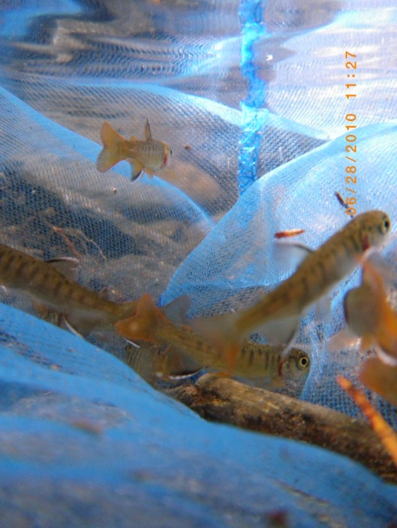On June 28, 2010, I surveyed an uncataloged stream flowing into the west side of Mendenhall Lake (Juneau-B2 Southeast Region) with a Garmin GPS and sampled with minnow traps and a hand net. The following table provides sampling information and the latitude and longitude of the upper and lower extents of the anadromous portion. The map illustrates sample locations and fish presence.

I deployed minnow traps and allowed them to soak for 1-3 hours. Net sampling with a small aquarium net was very effective and yielded most of the coho caught. This stream is extremely productive and has excellent spawning habitat in the lower reaches and good rearing throughout. The substrate consists of gravels, cobbles, and some larger boulders in the upper reach. I also observed spawning sockeye in the lower reaches in August.

Coho netted in Wesley Creek

|  |  |  |  |  |
| --- | --- | --- | --- | --- |
| NAME | DATE | COMMENTS | LAT | LONG |
| uncataloged stream | 6/28/2010 | on bridge along west glacier trail. | 58.418998 | -134.589004 |
| trap 1 | 6/28/2010 | set trap on left bank under leaning alder. | 58.4192 | -134.589004 |
| trap2 | 6/28/2010 | set trap in smmall ppool below lwd cascade. | 58.4192 | -134.589004 |
| trap 3 | 6/28/2010 | set trap in calm pool next to mossy rock. gravels, fines. | 58.420299 | -134.589996 |
| conflluence | 6/28/2010 | possible trib or sidechannel | 58.420799 | -134.591003 |
| braided channel | 6/28/2010 |  | 58.420898 | -134.591003 |
| net sample | 6/28/2010 | netted tens ofcoho fry; saw hundreds | 58.421001 | -134.591003 |
| net sample | 6/28/2010 | netted 1 coho under bank. | 58.4221 | -134.591003 |
| net sample | 6/28/2010 | netted three coho under bank. | 58.422298 | -134.591003 |
| observation | 6/28/2010 | observed approx. 9 coho | 58.4235 | -134.591003 |
| tributary | 6/28/2010 | confluence of trib and mainstem. | 58.423698 | -134.591003 |
| net sample | 6/28/2010 | netted two coho in possible trib | 58.4239 | -134.591003 |
| practice offset | 6/28/2010 | mike netting coho in trib | 58.424098 | -134.591003 |
| trib cont | 6/28/2010 | trib parallels mainstem | 58.424198 | -134.591003 |
| net sample | 6/28/2010 | mike netted 12-15 coho fry | 58.424499 | -134.591995 |
| side channel | 6/28/2010 | thought it was a trib...just a sidechannel.. | 58.424499 | -134.591995 |
| end of survey | 6/28/2010 | stream gradient steepens and begins a continuous climb. netted 2 coho. still need future investigation. | 58.4248 | -134.593994 |

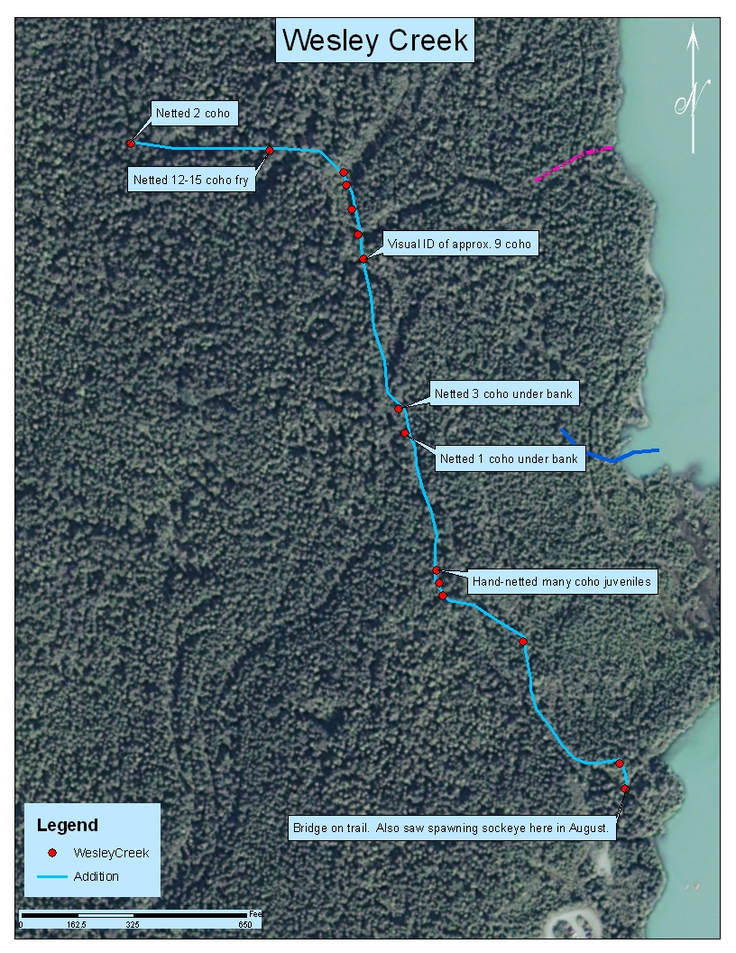

Tess Quinn

Alaska Department of Fish and Game

Division of Habitat

(907) 465-1635

tess.quinn@alaska.gov