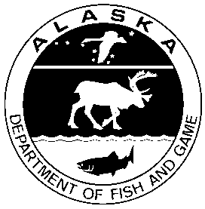
Alaska Department of Fish & Game

Aquatic Farm Operation Permit
Renewal or Transfer Application Form
5 AAC 41.280

ADF&G Aquatic Farm Operation Permit Number: DFG - - - -
Department of Natural Resources Aquatic Farm Lease # ADL

I wish to ☐ Renew my Aquatic Farm Operation Permit
I wish to ☐ Transfer my Aquatic Farm Operation Permit

- If this is an application to renew your Aquatic Farm Operation Permit, complete only the first section.
- If this is an application to transfer your Aquatic Farm Operation Permit, complete both sections.
- You must contact the Alaska Department of Natural Resources (907-269-8543) separately to apply for a lease transfer or renewal.

Current Permittee Information
Name:
Doing Business As:
Mailing Address:
City:
State:
Zip Code:
Phone:
Cell Phone:
Email:

New Permittee Information (if applicable)
Name:
Doing Business As:
Mailing Address:
City:
State:
Zip Code:
Phone:
Cell Phone:
Email:

A $100 renewal or transfer fee is required at the time that this application is submitted. Make checks payable to the Alaska Department of Fish and Game (ADF&G). Write your ADF&G permit number on the check. Mail your fee to:
ADF&G Aquaculture Section, Permit Coordinator
Division of Commercial Fisheries
P.O. Box 115526
Juneau, AK 99802-5526
Completed applications can be submitted by mail or emailed to dfg.dcf.aquaticfarming@alaska.gov.

The information contained herein is true and complete to the best of my knowledge.

Signature of Current Permittee Date

